R.A.F.T.

When to use this strategy: Before, during or after Reading
Targeted Reading Outcomes:
Understand the relationship between literature and its historical, social, and cultural contexts
Analyze and interpret elements of character development

What is it?
This is a great strategy that integrates reading and writing in a non-traditional way. It asks that students take what they have read and create a new product that illustrates their depth of understanding. The format is incredibly flexible and offers limitless opportunities for creativity for both you and your students. When you are first using a “RAFT” with your students, you will develop the specifics for each element in the acronym; they are as follows:

Role: In developing the final product, what role will the students need to “take on”? Writer? Character: Artist? Politician? Scientist?

Audience: Who should the students consider as the audience for the product? Other students? Parents? Community? School board? Other characters in the text?

Format: What is the best product that will demonstrate the students’ in-depth understanding of their interactions with the text? A writing task? Art work? Action plan? Project?

Topic: This is the when, who, or what that will be the focus/subject of the final product. Will it take place in the same time period as the novel? Who will be the main focus of the product? What event will constitute the centerpiece of the action?

What does it look like?
A teacher assigns (or students select) a role, audience, format, and topic from a range of possibilities. Below is a chart with a few examples in each of the categories; it is meant only as a sampling to spark new ideas and possibilities for building RAFTS:

Role | Audience | Format | Topic
· writer  · artist  · character  · scientist  · inventor  · juror or judge  · historian  · reporter  · therapist  · journalist | · self  · peer group  · government  · parents  · fictional character(s)  · committee  · jury  · judge  · activists  · animals or objects | · journal  · editorial  · brochure/ or booklet  · interview  · video or song lyric  · cartoon or game  · primary document  · critique  · biographical sketch  · newspaper article | · issue relevant to the text or time period  · topic of personal interest or concern for the role or audience  · topic related to an essential question

Summarization

When to use this strategy: After Reading

Targeted Reading Outcomes:
It helps students learn to determine essential ideas and consolidate important details that support them.
It enables students to focus on key words and phrases of an assigned text that are worth noting and remembering.
It teaches students how to take a large selection of text and reduce it to the main points for more concise understanding.

What is it?
Begin by reading OR have students listen to the text selection.
Ask students the following framework questions:
What are the main ideas?
What are the crucial details necessary for supporting the ideas?
What information is irrelevant or unnecessary?
Have them use key words or phrases to identify the main points from the text.

What does it look like?
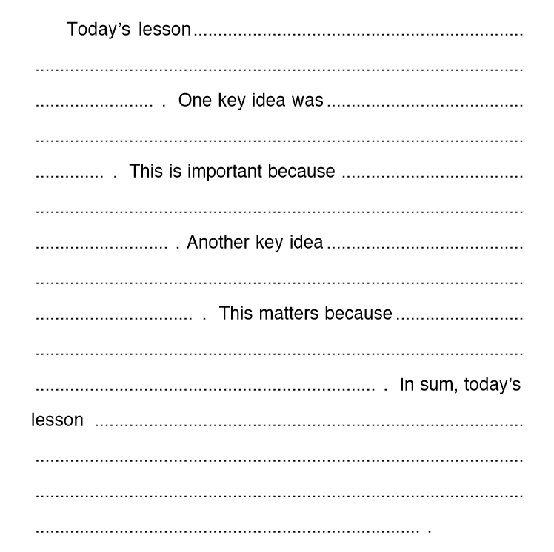

Think-Alouds

When to use this strategy: Before and during reading

Targeted Reading Outcomes:
It helps students learn to monitor their thinking as they read and improves their comprehension.
It teaches students to re-read a sentence, read ahead to clarify, and/or look for context clues to make sense of what they read.
It slows down the reading process and allows students to monitor their understanding of a text.

What is it?
- Begin by modeling this strategy. Model your thinking as you read. Do this at points in the text that may be confusing for students (new vocabulary, unusual sentence construction).
- Introduce the assigned text and discuss the purpose of the Think-Aloud strategy. Develop the set of questions to support thinking aloud (see examples below).
  - What do I know about this topic?
  - What do I think I will learn about this topic?
  - Do I understand what I just read?
  - Do I have a clear picture in my head about this information?
  - What more can I do to understand this?
  - What were the most important points in this reading?
  - What new information did I learn?
  - How does it fit in with what I already know?
- Give students opportunities to practice the technique, and offer structured feedback to students.
- Read the selected passage aloud as the students read the same text silently. At certain points stop and "think aloud" the answers to some of the pre-selected questions.
- Demonstrate how good readers monitor their understanding by rereading a sentence, reading ahead to clarify, and/or looking for context clues. Students then learn to offer answers to the questions as the teacher leads the Think Aloud.
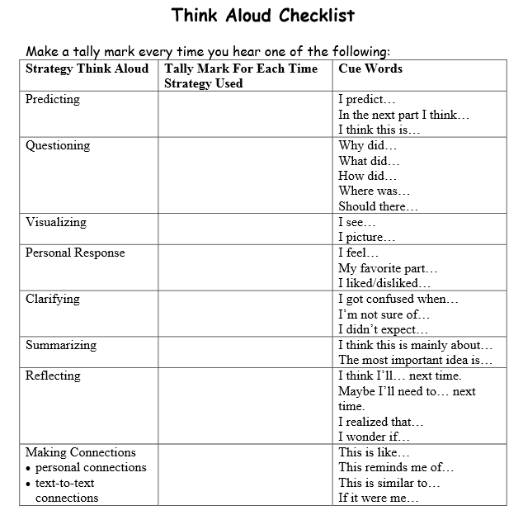
What does it look like?

Anticipation Guide

When to use this strategy: Before reading

Targeted Reading Outcomes:
They teach students to make predictions, anticipate the text, and verify their predictions.
They connect new information to prior knowledge and build curiosity about a new topic.

What is it?
- Construct the anticipation guide. Write four to six statements about key ideas in the text; some true and some false. Include columns following each statement, which can be left blank or can be labeled Yes, or No (Maybe can also be used).
NOTE: Teachers may wish to create an additional column for revisiting the guide after the material has been read.
- Model the process. Introduce the text or reading material and share the guide with the students. Model the process of responding to the statements and marking the columns.
- Read each of the statements and ask the students if they agree or disagree with it. Provide the opportunity for discussion. The emphasis is not on right answers but to share what they know and to make predictions.
- Read the text aloud or have students read the selection individually. If reading aloud, teachers should read slowly and stop at places in the text that correspond to each of the statements.
- Bring closure to the reading by revisiting each of the statements.
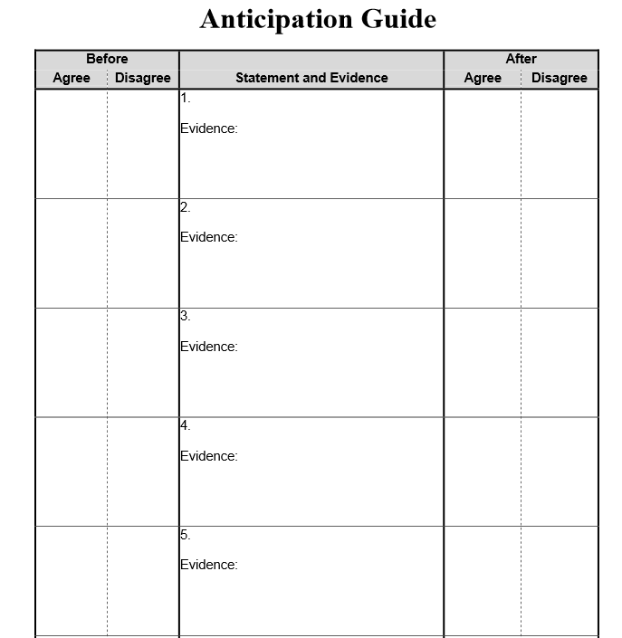
What does it look like?

Flow Chart/Flow Chart Graphic Organizer

When to use this strategy: After reading

Targeted Reading Outcomes:
They teach students a how to create a step by step process.
They order information and connect it.

What is it?
A type of diagram that represents a process. Boxes represent the topic and the arrows represent the order.

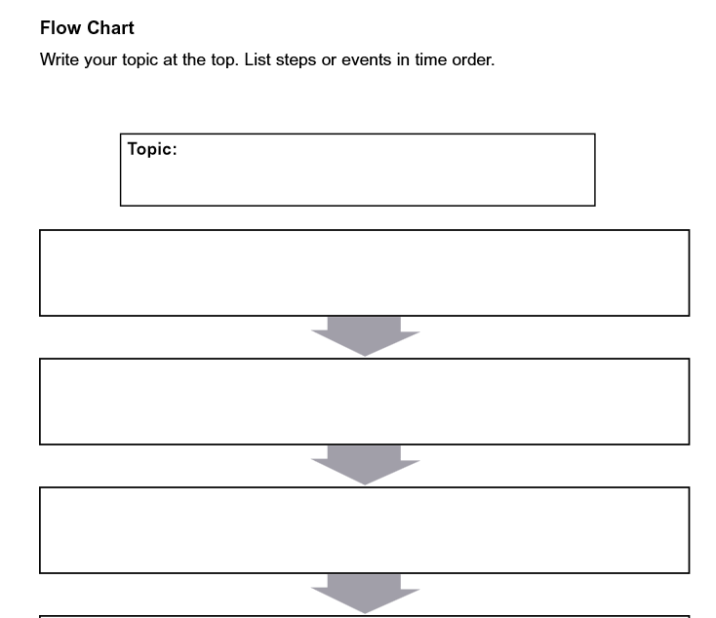
What does it look like?

Flow Chart Graphic Organizer
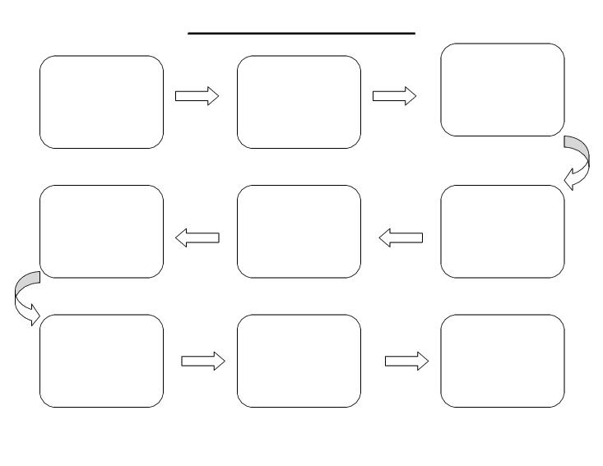

Placemat

When to use this strategy: After reading

Targeted Reading Outcomes:
Allows students to lay out various thoughts and distinguish essential information from secondary information
Allows for an individual point of view

What is it?
A strategy that has students take a summarized idea/view point/subject and place it in the center of the placemat. They write their thoughts/answers around the outside of the placemat.

What does it look like?

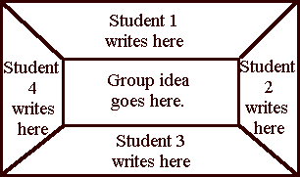

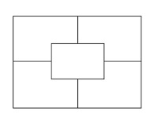

Whole to Part Graphic Organizer

When to use this strategy: After reading

Targeted Reading Outcomes:
Helps the student to take a large concept and break it down into smaller more manageable parts

What is it?
A strategy that has students takes a large concept and breaks it into smaller parts

What does it look like?

Circulatory System
Endocardium Cells
Endocardium
Arteries
Cardiomyopathy
Cardiac Tissue
Heart

Post Card Writing

When to use this strategy: Before and after reading

Targeted Reading Outcomes:
Allows for students to write in a personal format
Helps them to identify different aspects of a subject

What is it?
A strategy that has students read a text then write the details about the subject on a post card.

What does it look like?

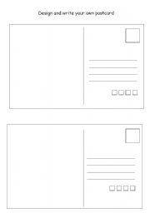

Cause and Effect

When to use this strategy: Before and after reading

Targeted Reading Outcomes:
Helps students develop analytical and critical thinking skills.
Helps to improve writing skills, reading comprehension, decision making, and analysis.

What is it?
A strategy that has students read a text then write out the cause (why) something happened and the effect (what) happens in a readable diagram.

What does it look like?

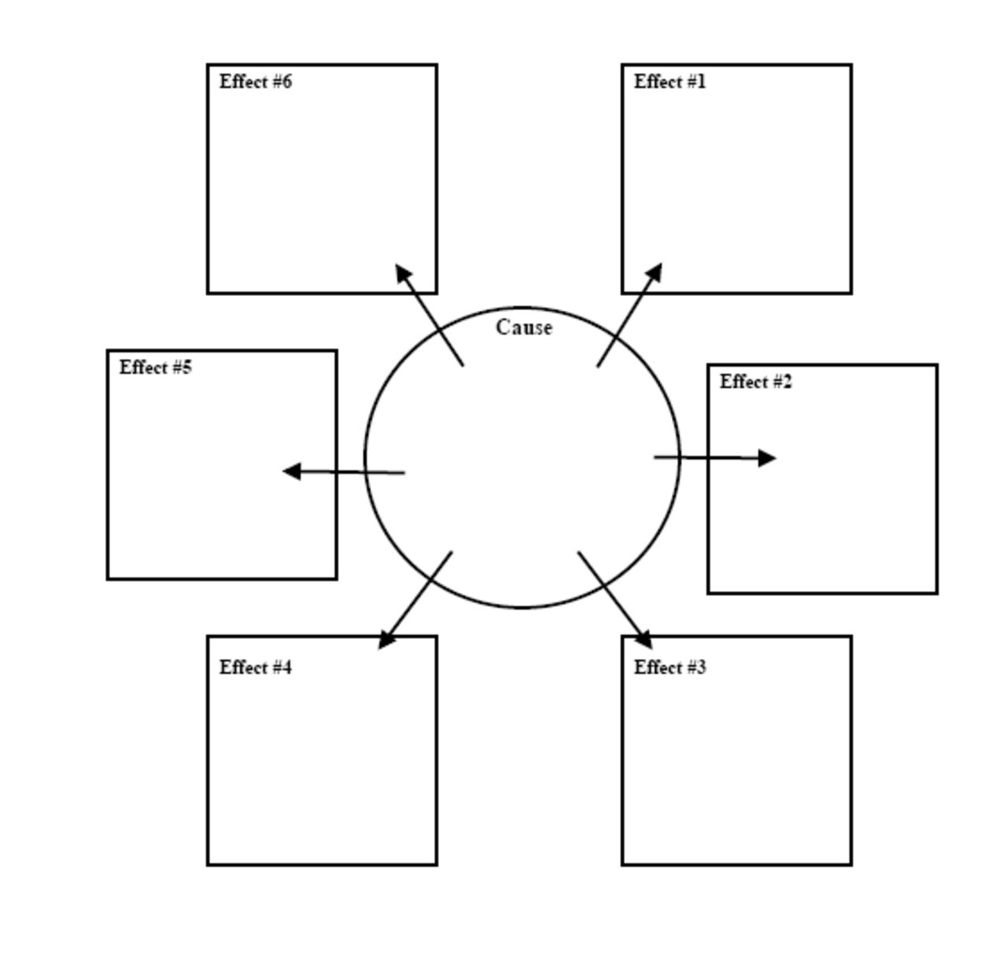

GIST

When to use this strategy: After reading

Targeted Reading Outcomes:
Helps students to identify important information
Helps students to summarize information

What is it?
A strategy that has students read a text and write out who, what, where, when and why. Students then summarize the information in 20 words or less.

What does it look like?

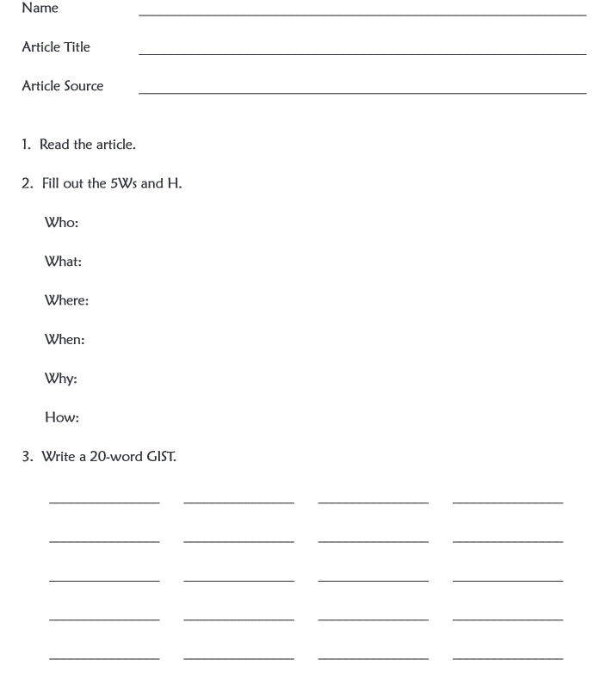

KWL

When to use this strategy: Before, during and after reading

Targeted Reading Outcomes:
Helps students to gather and organize information

What is it?
A strategy where students keep track of what they know(K), what they want to know (W), and what they have learned (L) about a topic.

What does it look like?

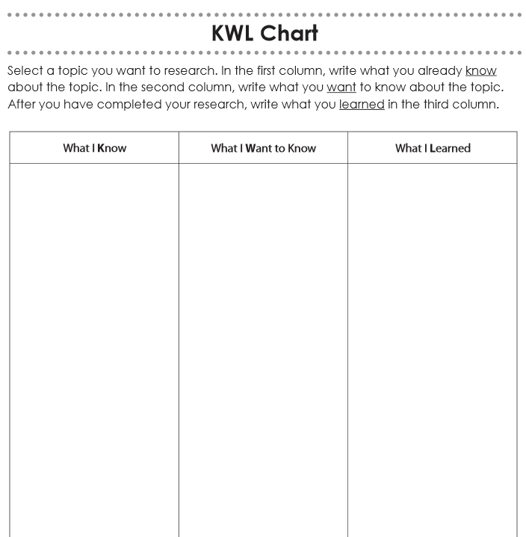

Webbing Chart

When to use this strategy: Before, during and after reading

Targeted Reading Outcomes:
Helps to develop students' ability to perceive relationships among ideas, concepts or events
Helps to generate and organize ideas
Helps to encourage students to recall prior knowledge and experiences
Helps to increase students' knowledge and vocabulary

What is it?
Webbing is a method of visually representing relationships among ideas, concepts or events. During this procedure, ideas and information are explored and organized. The resulting web or pattern of relationships is determined by the participants' knowledge and previous experiences, and by the purpose for webbing.

What does it look like?

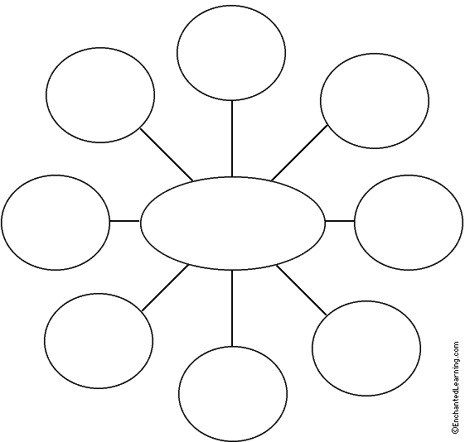

Compare and Contrast

When to use this strategy: After reading

Targeted Reading Outcomes:
Help students explain similarities and differences between two things or ideas.

What is it?
Give students two things that you would like to compare and contrast, and have students brainstorm how they are alike and how they are different. Students can make lists of these ideas, or they could discuss their thoughts with a partner or group. Have students share their ideas with the class, as this will enable students to see different ideas to compare and contrast that they may not have thought of themselves.

What does it look like?

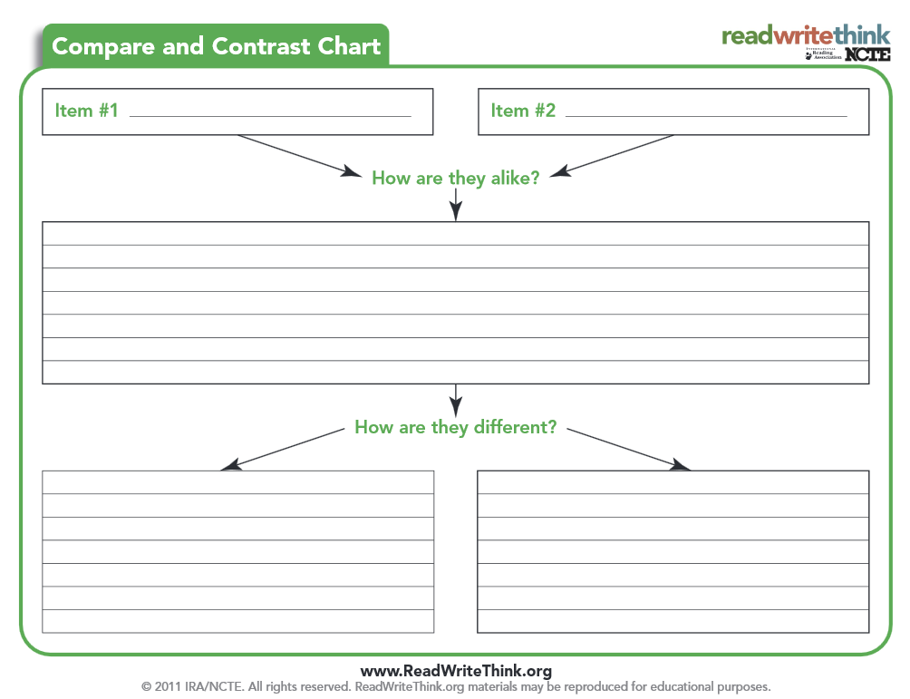

Highlighted Reading

When to use this strategy: During and after reading

Targeted Reading Outcomes:
Help students organize what they have read by selecting what is important.
This strategy teaches students to highlight/underline ONLY the key words, phrases, vocabulary, and ideas that are central to understanding the reading.

What is it?
Selective Highlighting/Underlining is a flexible strategy that may be tailored to fit various types of information, and different skill-levels. You can employ the selective highlighting/underlining for many different instructional purposes (i.e., key vocabulary; main ideas). This strategy can also be integrated with the use of technology and electronic information such as eBooks (see example below). As students study, selective highlighting/underlining helps them learn to pay attention to the essential information within a text.
What does it look like?
Introduce students to the Selective Highlighting/Underlining strategy and discuss the purpose of the activity (i.e., focus on vocabulary, main ideas, etc.). Then model the procedure to ensure that students understand how to use Selective Highlighting/Underlining. Give students time and means to practice the technique and reinforce successful performance. Monitor and support students as they work.
Teacher should ask students to:
- Read through the selection first.
- Reread and begin to highlight main ideas and their supporting details.
- Highlight only the facts which are important or the key vocabulary not the entire sentence.
- After highlighting, look at what they have highlighted and summarize what they read.
- Take what was highlighted and write a summary paragraph.
Teachers may wish to have students use various colors of highlighters to identify main ideas from details (e.g., use orange to represent main ideas and yellow to represent supporting details).
When using an eBook, teachers should ask students to:
- Read through the selection first.
- Reread and select a portion of the text that the student wishes to highlight by highlighting or changing the font of the text OR using text boxes for comments.
  - From the menu select the add text box option.
  - Type in the comment into the text box and click anywhere outside the text box to finish.
- Summarize what they read by using the highlighted text or text boxes to write a summary paragraph.

Online Literacy Resources:

Make a Magazine – www.flipsnack.com – can create a digital magazine, write, proof and edit

Story Board – Show Me-iPad App or white board with iPhone to record video document camera for demonstration

Role Paly – www.xtranormal.com/index - create an animated video
Flip Book – www.Readwriethink.org – can use this site to create a flip book – type flip book into the search box

